Some Golden Rules to Remember:
- Keep the muzzle pointed in a safe direction at all times
Never point your firearm at anything you do not intend to shoot, a safe direction may be defined as a direction that will not cause harm if the firearm was to be accidently discharged. May not occur if the firearm is kept in a safe direction at all times. Extreme car must be taken and maintained at all times when loading and unloading a firearm. Always treat an empty firearm as a loaded firearm and as we have heard from time to time I thought it was empty, safety glasses should be worn at all times when discharging a loaded firearm
- Firearms when not in use should not be loaded
The only time your firearm should be loaded is when you are going to use it (unless you are in law enforcement, security, armed services or other lawful activities).Never pass a loaded firearm to another person always ensure it is in a safe state prior to handing it to someone else, always keep the action in the open position or if a break action shot gun it must be in the broken state when handing the firearm to someone, if you have an automatic firearm the receiver must be in the open position when not in use, always double check that the firearm is in a safe state. Extra care must be undertaken when children are in the household where firearms are stored and double extra care must be undertaken when children are at shooting events or in the field where firearms are being used. Do not attempt to cross a river or creek on foot with a loaded firearm, never climb over or under a barbed wire fence with a loaded firearm, and never pass a loaded firearm to someone on the other side of a fence
- Safety catches and systems
Is your safety catch or device “safe” (the quick answer is NO), under no circumstances you should never rely or your firearms safety catch or device for the satisfaction of your firearm is in a safe mode, keep your fingers off the trigger until you are ready to discharge the firearm sometimes this can be misleading that the safety may be on when in fact it may not be, this could result in grave consequences if the firearm discharged. Human error is often the cause of a firearm incident that causes injury
- Sights on a target
Always check that your target is a lawful target when in the field hunting, always check the background behind your target a house, other animals, human beings may be in the line of fire as bullets from high calibre firearms travel great distances and a ricochet could result if the back drop of your target is not capable of stopping your bullet or you miss the target. Never shoot into water or rocks as a ricochet may result, people have died and been seriously maimed and injured as result of ricochets, remember pick and choose your target carefully and only discharge the firearm when completely safe to do so
- Correct ammunition and reloading
Each firearm is unique and may require a particular round or brand of ammunition, read the manufacturer’s instructions for the correct gage, size ammunition that suits your firearm, if reloading please ensure that only the recommended loads are loaded into your cases or hulls, an overload or higher charge does not necessarily mean a better load, remember an overload may and could result in serious injury or death, due diligence must be adhered to at all times whilst reloading ammunition of any variety and size. Always keep your ammunition and reloading components stored and locked in a well-ventilated and dry area and out of reach of children at all times
- Misfire and or fails to fire one the trigger is pulled
If for any reason your firearm fails to fire once the trigger is squeezed immediately remove your finger from the trigger and remember the # 1 rule (keep the muzzle aimed or pointed in a safe direction. Once satisfied that the firearm in in a safe position to unload the misfired cartridge or bullet remove it and place it in a safe place until it can be disposed of in a safe manner
- Eye and ear (PPCE) protection
Your eyes and ears are one of the most important thing we human have and sometimes we place them under great pressure and sometimes pain to achieve what we want to do, shooting is amongst these things and or sport we like to do and to help us enjoy and achieve these goals and to help protect us from serious injury or some form of permanent disability is the use of personal protective clothing and equipment (PPE) as it is commonly referred to. It is highly recommended that whist shooting in the field or at a competition event that eyewear and ear protection should be worn at all times, sometimes long sleeved clothing is of an assistance and added protection from the sun’s rays and other weather elements and is highly recommended at all times
- Obstruction (barrel) and other
One golden rule must never be broken or taken for granted and that is an obstruction in the barrel and in some cases barrels, prior to loading your firearm check the that the barrel or barrels are free from obstruction, this simple check may safe your or someone else’s life. Never put the barrel of any firearm into the ground as a blockage will result in the barrels bulging and possibly exploding which may result in serious injury and or death.
- Modifications and alterations
Alterations and or modification to your or any firearm should be completed by a qualified gunsmith and or stock maker, a good warning and advice is to never attempt to alter or modify your firearm in any way shape or form apart from voiding any warranty it is not recommended that a none qualified person should attempt any modification whatsoever in the interest of your and or a family members safety, this may and could prevent a serious injury or even death. Regular servicing and maintenance by a qualified person should see your firearm in good condition for many years to come and remember your firearm is only as good as it kept, correct lubricants as per the manufacturers recommendations should be used at all times
- Characteristics and knowing you firearm
As you are aware like all other machines, vehicles, tools and so on a firearm is no different from the previously mentioned items, it is imperative that you get to know your firearm from but to the end of the barrel, like cars no motor vehicle is the same as with firearms, when you purchase a new or second hand firearm you need to familiarise yourself with it as soon as possible and get to know how it works, how it feels when fired, where it is shooting, read the hand book that may come with the firearm, if a second hand purchase is made ask the seller or the local firearm reseller if a manual is available, this is an important document that should be read, re-read and completely understood before any live firing is undertaken

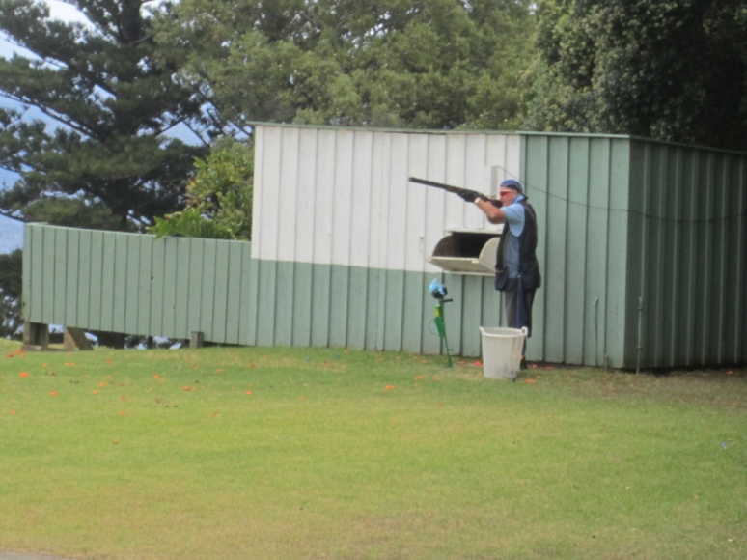
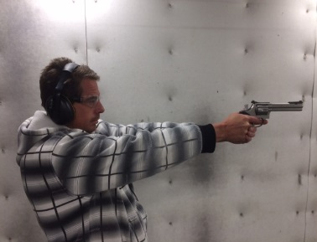
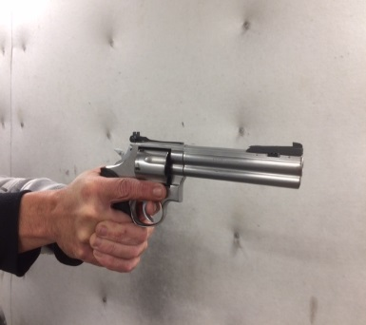
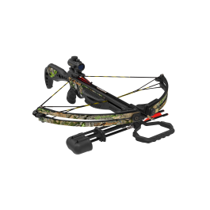
Garry’s Contracting Services
0408 156 655
Email:gwjbarnes@bigpond.com
www.garryscontractingservices.com.au

FIREARM SAFETY COURSES

A B C D H M & COLLECTORS

Garry’s Contracting Services
0408 156 655
Email:gwjbarnes@bigpond.com
www.garryscontractingservices.com.au

Together we can stay safe

10618NAT Course in Firearm Safety (approved for firearms licensing in Queensland) Statement of Attainment issued by
Queensland Training Centre (RTO) # 40463

General Information
Garry’s Contracting Services provides Firearm Safety Courses (for QLD) in the following categories A B C D H M and Collectors that are required to obtain a QLD Firearms Licence.

We provide personal service with an emphasis
on safety.

We offer one on one training, (additional cost may be incurred)

Training and post course coaching can be
arranged to help pursue your particular
shooting discipline.

WHAT TO BRING:
- Drivers licence or other form of photo ID
- Enclosed footwear
- Please do not wear singlets
- Anything you may wish to eat or drink
- (refreshments available at RCCTC)
- All training material PPEC, Firearms & Ammo supplied

WHEN:
We run regular courses on Saturdays / Sundays / Monday – Thursday and or other days as required.

Courses can and may be conducted at other times by arrangement.

Our specialty is after hours and Regional Training as we cater for the person that has the ever-busy lifestyle, (some additional fees may be required).

Private firearms coaching (clay target / handgun / crossbow) available.

WHERE:
Our courses are held at the Redcliffe City Clay Target Club / Belmont / RPIIPC and or other Regional Clubs / Ranges as required for categories ABCDHM and Collectors.

Category H C D M are held at the RPIIPC / Belmont Range and or other approved ranges as and when required.

SESSION DETAILS:
Each session includes a theory presentation including videos and exam, plus a practical assessment, which includes hands on dry and live fire.
Take home booklet, all other training material provided.
Our sessions are held as smaller classes (max 10) to give a more personalised and tailored session. After hours’ theory and live fire can be arranged by appointment.

Refresher: Refresher courses are available for those who have a licence and or wish to brush up on their skills and knowledge, a small fee will apply for this session.
Payment:
All safety courses must be paid in full before commence of course, (unless other payment prior arrangements are approved)

One on One sessions may incur a $50 Surcharge

Direct debit confirmation must be completed by the Thursday prior to the course date, (Cash payments also accepted) by prior arrangement.
Bank Details:
Westpac Kippa-Ring: BSB: 034 059 – A/C: 159 628
To arrange a session or for more details, please contact:
Garry’s Contracting Services
Garry Barnes: 0408 156 655
Bevan Barnes: 0417 721 645
Email:gwjbarnes@bigpond.com

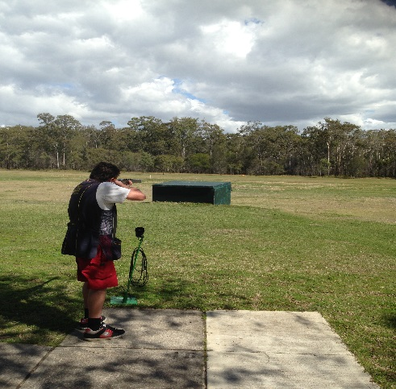
Student in training lesson to shoot Clay Targets at Redcliffe Clay Target Club

Eligibility for Safety Course Participation & Licencing Requirements

The QLD Weapons Act defines the licencing requirements and use of firearms in QLD.

For participation in a firearms safety Training Course a person must not be disqualified or prevented from obtaining a licence under the Weapons Act 1980.

A person may possess and use a weapon without a licence under certain circumstances.
These are:
- A person who is eligible to obtain a licence may have possession and use a weapon at a range approved for the category of weapon, if they have produced photographic identification and signed the appropriate forms. Possession and use must be supervised by a range officer.
- Full licence holders must be at least 18 years of age and be a fit and proper person
- Children of at least 11 years of age can use certain firearms, with adult supervision, under a minor’s licence.
- A person is ineligible to hold a Weapons Act Licence if, within the past five years, they have been convicted of offences including misuse of drugs, or weapons, and the use or threatened use of violence. A person is ineligible to hold a Weapons Act Licence if they are or have been the subject of a domestic violence order in the previous five years to the course.
More information is available on the QLD Police website: http://www.police.qld.gov.au/programs/weaponslicensing/

