FIREARM SAFETY COURSES
11029NAT Course for Firearms Safety (approved for Firearms Licensing in Queensland) Statement of Attainment Issued by Queensland Training Centre RTO # 40463

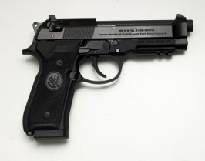
For Bookings Phone: 0408 156 655 or
0417 721 645
Email: gwjbarnes@bigpond.com

www.Garry’s Contracting Services.com.au
Want to get your firearm Licence?
**Don’t delay book to-day**
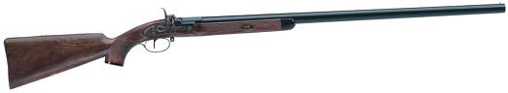

We have competitive rates – personal service – smaller class and or private class - full assistance given to gain full satisfaction – prompt service – out of (town, Regional and or Country) area training and assessing can be by arrangement.

Smaller classes to provide you with better expertise and to assist you in obtaining your firearm safety certificate.
Classes normally held Mondays – Thursdays, Friday, and Saturday or Sundays are by arrangement and Range Availability.
Regional Classes are also offered please call Garry re this option.

- Categories A B C D H M - Collectors – and Collectors R
- Option of semi enclosed / or Indoor / outdoor range for HCDM or open air Clay Target Range for A B C (catering for different shooting disciplinary to suit your requirements)
- Additional post safety certificate training conducted to assist you to pursue your shooting elements or particular discipline
- One on one training can be arranged by appointment, (a $60 surcharge for this option).
- Bookings essential
- Cost starting from $150
- Take home (firearm material and learnings including safety code) to keep booklets
- After class specials for those that may want extra training on a certain firearm or just to have a few more rounds (depending on numbers and available range time, additional fees apply)
- We can offer other services as outlined below pictures

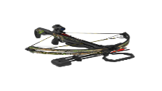
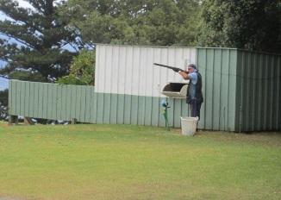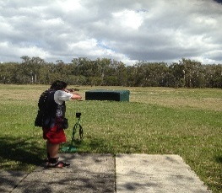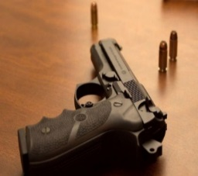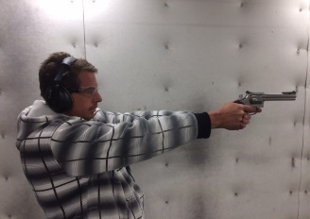

**ALL PHOTOS TAKEN UNDER CONTROLLED CONDITIONS**
Other Sevices include

Workplace Health & Safety Workplace Inductions and Development
Workplace Inspections Vehicle Hygiene Inspections

